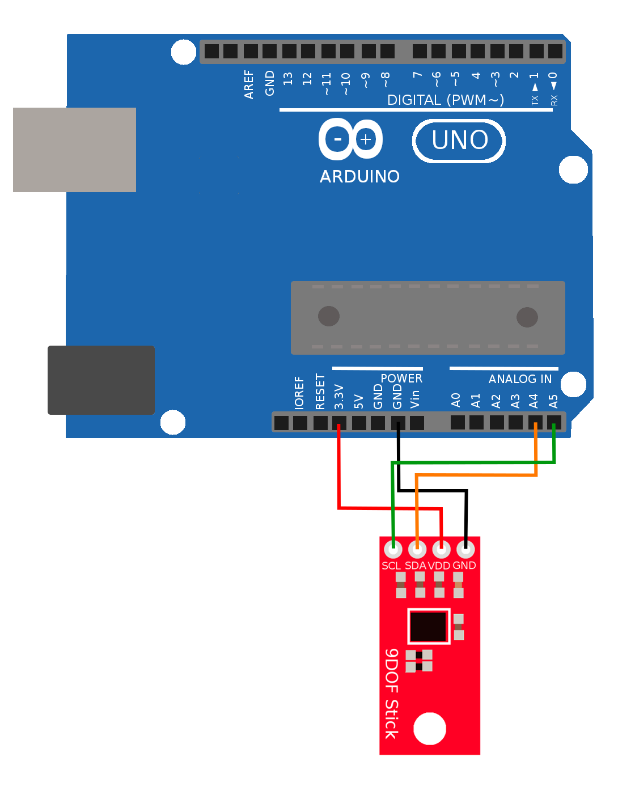
Wiring and Testing the 9DOF

